BÀI TẬP VỀ NHÀ

* Hình tròn

Code:

l1=50; l2=40;

clc

syms t pi t1 t2;

pi=3.14

for t=0:0.05:2\*pi

X=40+10\*cos(t);

Y=40+10\*sin(t);

c2=(X^2+Y^2-l1^2-l2^2)/(2\*l1\*l2);

s2=sqrt(abs(1-c2^2));

t2=atan2(s2,c2);

c1=(l1+l2\*c2)\*X+l2\*s2\*Y;

s1=(l1+l2\*c2)\*Y-l2\*s2\*X;

t1=atan2(s1,c1);

Px=l1\*cos(t1)+l2\*cos(t1+t2);

Py=l1\*sin(t1)+l2\*sin(t1+t2);

subplot(2,1,1)

plot(t,t1,'\*',t,t2,'\*');

pause(0.1);

xlabel('t');

ylabel('Rotation');

hold on

subplot(2,1,2)

plot(Px,Py,'\*');

xlabel('x(cm)');

ylabel('y(cm)');

pause(0.1);

hold on

end

ảnh matlap

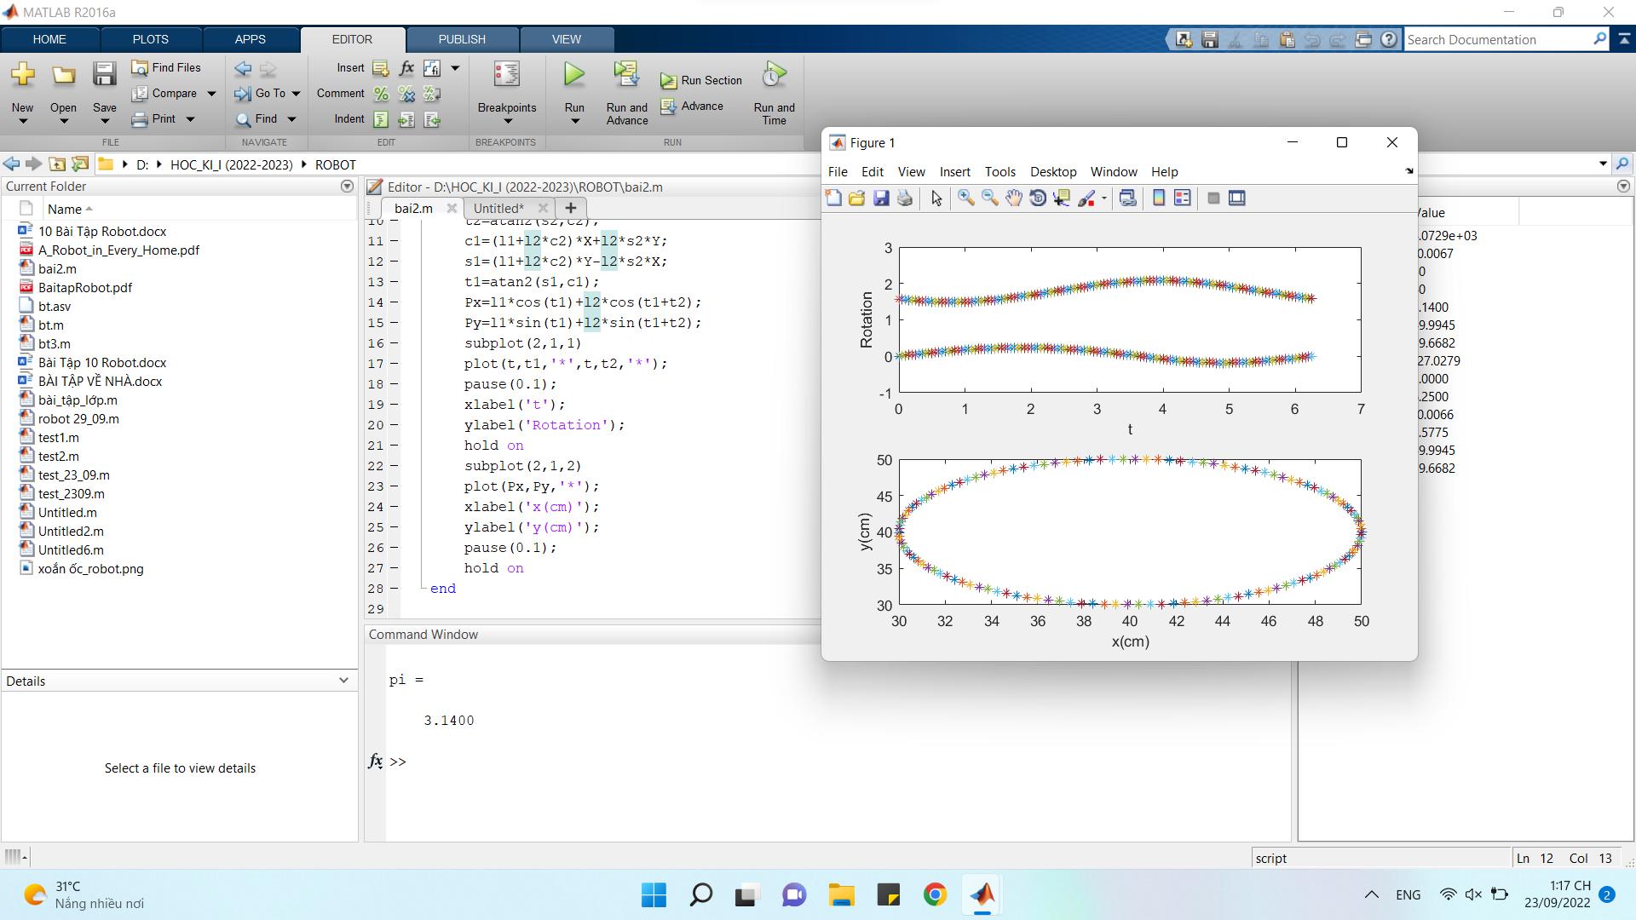

* Trái tim

Code:

l1 = 10;

l2 = 15;

for t=0:pi/100:2\*pi

x = 16\*sin(t)^3;

y = 13\*cos(t)-5\*cos(2\*t)-2\*cos(3\*t)-cos(4\*t);

c2 = (x^2+y^2-l1^2-l2^2)/(2\*l1\*l2);

s2 = sqrt(abs(1-c2^2));

t2 = atan2(s2,c2);

c1 = x\*(l1+l2\*cos(t2))+l2\*sin(t2)\*y;

s1 = y\*(l1+l2\*cos(t2))-l2\*sin(t2)\*x;

t1 = atan2(s1,c1);

Px = l1\*cos(t1)+l2\*cos(t1+t2);

Py = l1\*sin(t1)+l2\*sin(t1+t2);

subplot(2,1,1)

plot(t,t1,'\*',t,t2,'+'); pause(0.01)

xlabel('t');

ylabel('Rotation');

hold on;

subplot(2,1,2)

plot(Px,Py,'d')

xlabel('x(cm)');

ylabel('y(cm)'); pause(0.01);

hold on;

end

ảnh matlap

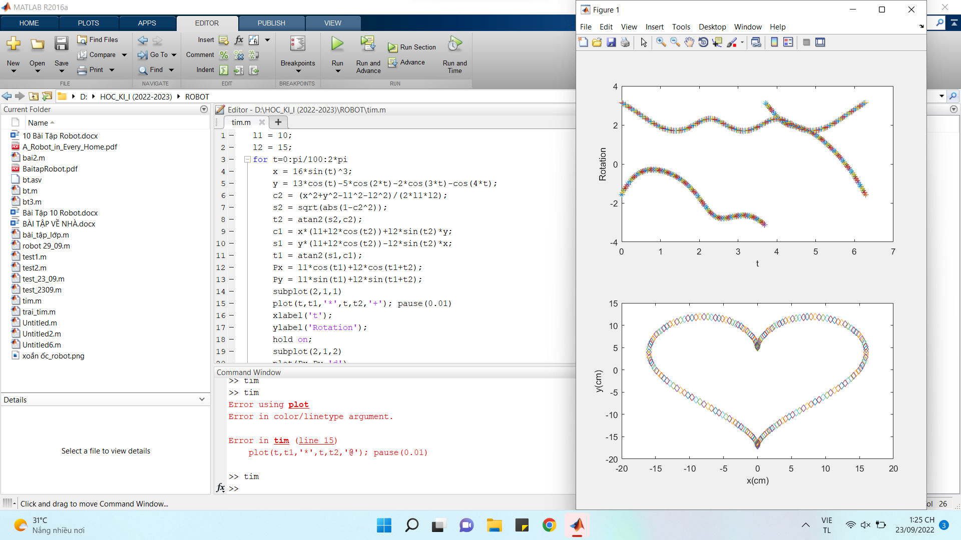

* Bướm

code:

l1 = 10;

l2 = 15;

for t=0:pi/100:2\*pi

x = sin(t)\*(2.27^cos(t)-2\*cos(4\*t)+(sin(t/12))^5);

y = cos(t)\*(2.27^cos(t)-2\*cos(4\*t)+(sin(t/12))^5);

c2 = (x^2+y^2-l1^2-l2^2)/(2\*l1\*l2);

s2 = sqrt(abs(1-c2^2));

t2 = atan2(s2,c2);

c1 = x\*(l1+l2\*cos(t2))+l2\*sin(t2)\*y;

s1 = y\*(l1+l2\*cos(t2))-l2\*sin(t2)\*x;

t1 = atan2(s1,c1);

Px = l1\*cos(t1)+l2\*cos(t1+t2);

Py = l1\*sin(t1)+l2\*sin(t1+t2);

subplot(2,1,1)

plot(t,t1,'-o',t,t2,'--o'); pause(0.01)

xlabel('t');

ylabel('Rotation');

hold on;

subplot(2,1,2)

plot(Px,Py,'d')

xlabel('x(cm)');

ylabel('y(cm)'); pause(0.01);

hold on;

end

bốn cánh

code:

l1 = 20;

l2 = 15;

for t=0:pi/100:2\*pi

x = sin(2\*t)\*cos(t);

y = sin(2\*t)\*sin(t);

c2 = (x^2+y^2-l1^2-l2^2)/(2\*l1\*l2);

s2 = sqrt(abs(1-c2^2));

t2 = atan2(s2,c2);

c1 = x\*(l1+l2\*cos(t2))+l2\*sin(t2)\*y;

s1 = y\*(l1+l2\*cos(t2))-l2\*sin(t2)\*x;

t1 = atan2(s1,c1);

Px = l1\*cos(t1)+l2\*cos(t1+t2);

Py = l1\*sin(t1)+l2\*sin(t1+t2);

subplot(2,1,1)

plot(t,t1\*180/pi,'-o',t,t2\*180/pi,'--o'); pause(0.01)

xlabel('t');

ylabel('Rotation');

hold on;

subplot(2,1,2)

plot(Px,Py,'d')

xlabel('x(cm)');

ylabel('y(cm)'); pause(0.01);

hold on;

end

6 cánh

Code:

l1 = 20;

l2 = 15;

for t=0:pi/100:2\*pi

x = cos(3\*t)^2\*cos(t);

y = cos(3\*t)^2\*sin(t);

c2 = (x^2+y^2-l1^2-l2^2)/(2\*l1\*l2);

s2 = sqrt(abs(1-c2^2));

t2 = atan2(s2,c2);

c1 = x\*(l1+l2\*cos(t2))+l2\*sin(t2)\*y;

s1 = y\*(l1+l2\*cos(t2))-l2\*sin(t2)\*x;

t1 = atan2(s1,c1);

Px = l1\*cos(t1)+l2\*cos(t1+t2);

Py = l1\*sin(t1)+l2\*sin(t1+t2);

subplot(2,1,1)

plot(t,t1\*180/pi,'-o',t,t2\*180/pi,'--o'); pause(0.01)

xlabel('t');

ylabel('Rotation');

hold on;

subplot(2,1,2)

plot(Px,Py,'d')

xlabel('x(cm)');

ylabel('y(cm)'); pause(0.01);

hold on;

end